Yashotkarsh Work Report
16/02/2026 Monday
Competitor Research
Creating Report
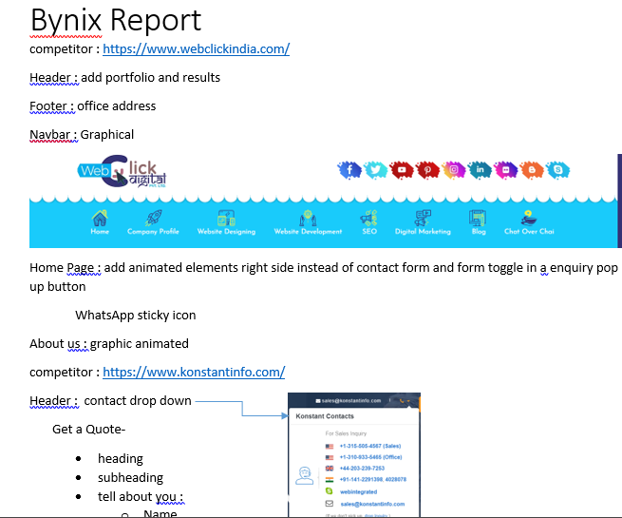
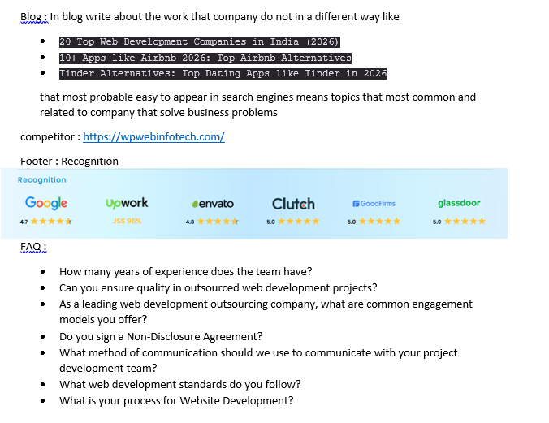
Api Creation
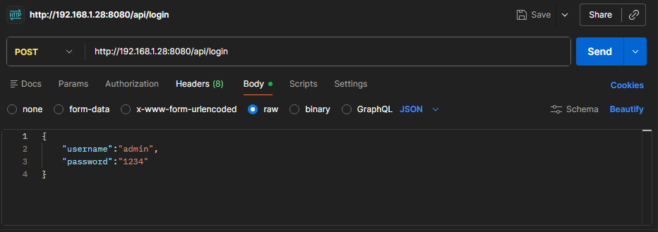
Login Controller:
package com.example.demo.controller;
import com.example.demo.security.JwtUtil;
import org.springframework.web.bind.annotation.PostMapping;
import org.springframework.web.bind.annotation.RequestBody;
import org.springframework.web.bind.annotation.RestController;
import java.util.Map;
@RestController
public class LoginController {
private final JwtUtil jwtUtil;
public LoginController(JwtUtil jwtUtil) {
this.jwtUtil = jwtUtil;
}
@PostMapping("/api/login")
public String login(@RequestBody Map<String, String> body) {
String username = body.get("username");
String password = body.get("password");
if ("admin".equals(username) && "1234".equals(password)) {
return jwtUtil.generateToken(username);
}
return "Invalid credentials";
}
}

Trying to implement JWT Authentication
JwtUtil.java
package com.example.demo.security;
import io.jsonwebtoken.Jwts;
import io.jsonwebtoken.SignatureAlgorithm;
import io.jsonwebtoken.security.Keys;
import org.springframework.beans.factory.annotation.Value;
import org.springframework.stereotype.Component;
import java.util.Date;
@Component
public class JwtUtil {
@Value("${jwt.secret}")
private String secret;
@Value("${jwt.expiration}")
private String expiration;
public String generateToken(String username){
return Jwts.builder()
.setSubject(username)
.setIssuedAt(new Date())
.setExpiration(new Date(System.currentTimeMillis() + expiration))
.signWith(Keys.hmacShaKeyFor(secret.getBytes()), SignatureAlgorithm.HS256)
.compact();
}
public String extractUsername(String token) {
return Jwts.parserBuilder()
.setSigningKey(secret.getBytes())
.build()
.parseClaimsJws(token)
.getBody()
.getSubject();
}
}
JwtFilter.java
package com.example.demo.security;
import jakarta.servlet.FilterChain;
import jakarta.servlet.ServletException;
import jakarta.servlet.http.HttpServlet;
import jakarta.servlet.http.HttpServletRequest;
import jakarta.servlet.http.HttpServletResponse;
import org.springframework.security.authentication.UsernamePasswordAuthenticationToken;
import org.springframework.security.core.context.SecurityContextHolder;
import org.springframework.stereotype.Component;
import org.springframework.web.filter.OncePerRequestFilter;
import java.io.IOException;
import java.util.ArrayList;
@Component
public class JwtFilter extends OncePerRequestFilter {
private final JwtUtil jwtUtil;
public JwtFilter(JwtUtil jwtUtil) {
this.jwtUtil = jwtUtil;
}
@Override
protected void doFilterInternal(HttpServletRequest request,
HttpServletResponse response,
FilterChain filterChain)
throws ServletException, IOException {
String header = request.getHeader("Authorization");
if(header !=null && header.startsWith("Bearer ")){
String token = header.substring(7);
String username = null;
try {
username = jwtUtil.extractUsername(token);
} catch (Exception e) {
response.setStatus(HttpServletResponse.SC_UNAUTHORIZED);
return;
}
UsernamePasswordAuthenticationToken authToken =
new UsernamePasswordAuthenticationToken(username, null, new ArrayList<>());
SecurityContextHolder.getContext().setAuthentication(authToken);
}
filterChain.doFilter(request, response);
}
}

